Lot # |  | Description
9391 | 1 | Dyeing Printing and Finishing
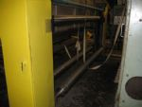 |  | Compensator / 3-Roll, 120” wide  Compensator 3-Roll stainless steel, 120” wide x 6” diameter
5900 | 1 | Lab Equipment
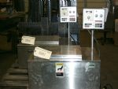 |  | Dye machine / Ahiba Polymat / Lab Dye  Ahiba Polymat Lab Dye Machine, Tag#1: Type PM.03, Nr. 83122, 3.320 Volt, 15 Amp, 6600 Watt, 60 Hz. It has beakers
4939 | 1 | Lab Equipment
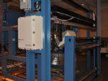 |  | Color Management System /Hunter / SpectraProbe XE  Hunter Lab Color Management System SpectraProbe XE, Model 80223158, S/N 039723801A, 104” wide  The SpectraProbe XE online color measurement system can be used to measure the color of the fabric as it exits in a textile finishing range (typically after the drying cans or tenter oven). The sensor traverses over the surface of the fabric so side-center-side shading differences can be assessed and immediate adjustments made to the range based upon these values. The colormetric results are displayed on screen and users are alarmed when the tolerances for these are exceeded  The system has provision for analog/digital outputs, which serve to report color data to a plant DCS or PLC control system allowing color measurement data to be used in the control of range process variables
5586 | 1 | Lab Equipment
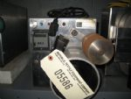 |  | Tester / Accu-Reel / Roving Tester  Accu-Reel (Roving Tester), Model AR-18, S/N 128758
5742 | 1 | Lab Equipment
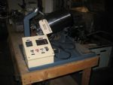 |  | Dry Cleaning and washing / Lab machine  Dry Cleaning and washing lab machine, Model 6523, S/N 15014. Motor: DC Gear motor 1/8 HP, Model 507-02-126A, 90 VDC Volts 1.5 Amps, 65 rpm, Torque 63 IN lbs

Lot # |  |  | Description
5891 | 1 |  | Lab Equipment
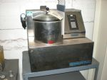 |  |  | Tester / Raitech / Quickwash Plus, fabric shrinkage tester  Quickwash Plus, made by Raitech Inc., Charlotte, holds (8) samples, holds about 1 pound, washes and dries. US Patent No. 5.450.642
5610 | 1 |  | Lab Equipment
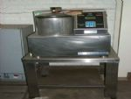 |  |  | Tester / Quickwash Plus / Fabric shrinkage tester  Quickwash Plus fabric shrinkage tester, washer & dryer. Washer size: 10” dia. x 6” deep. 110 Volts.
5995 | 1 |  | Lab Equipment
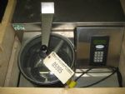 |  |  | Tester / Raitech / Quickwash Plus, fabric shrinkage tester  Quickwash Plus, made by Raitech Inc., US Patent No. 5,450,642. EPP 93,910,491,5. 120Volt AC.  Ariston hot water heater with unit, Model P155, S/N 971121, 150 psi, KPA 1034, 11 Amp, 1 ph, 120 Volt AC, 1350 watt
5996 | 1 |  | Lab Equipment
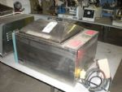 |  |  | Washer / Lindberg / Blue M, Lab Equipment  Lindberg Blue M Model WB-1130A Washer, S/N 9303-27, B.O.M R4-00001. Temp. Range 5° C above AMB. To 90° C. 120 Volt, 1 ph, 50/60 Hz. Stainless steel, inside box 20” wide x 18” front to back x 10” deep
5976 | 1 |  | Lab Equipment
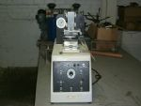 |  |  | Tester / Universal / Wear tester, motorized, yr. 1999  Universal Wear Tester Model UWT, motorized, year 1999, S/N 11379. 120 AC Volt, 8 amp, 60 Hz, 1 phase
4919 | 1 |  | Lab Equipment
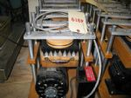 |  |  | Tester / CSI Abrasion Tester, yr. 1992  CSI Abrasion Tester Model CS-53-317, 4 positions, year 1992, 120 Volt, 3 Amp, 1 ph
Lot # |  |  | Description
4920 | 1 |  | Lab Equipment
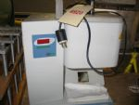 |  |  | Plastometer / Extrusion plastometer, yr. 2002  Extrusion Plastometer S/N 20007L39, year 2002, 50 vac, 220 Volt, 1 ph, 4 Kw
4921 | 1 |  | Lab Equipment
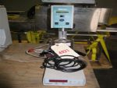 |  |  | Viscometer / Brookfield / With temperature controller  Brookfield Viscometer Model RVDVE115, Ser. No. E7269, 115 Volt, 50/60 Hz, Power 20 watts.  Temperature controller: Model Brookfield 106, Range 50c-300c, Supply 85-265 vac, 1 ph, 50/60 Hz, 250 watts max. load, 2 Amp GMA Fuses, Ser. No. 0324-4367
7156 | 2 |  | Dyeing Printing & Finishing
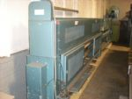 |  |  | Opener / Birch Brothers / 134” wide  Birch Brothers Fabric Opener, 134” wide  2 Scroll Rolls, 134” wide x 5” diameter  2 Covered Rolls, 134” wide x 5” diameter  Scroll drive motor: 2 HP, Model 7VE 145THTN6046BAP, Volt 230/460, Type TTS, Amp 6.0 / 3.0, 1750 rpm, 60 Hz  Lot# 07156: S/N 00696420-06/09-07, Tag S/N 222 22, Order No. 104 752  Lot# 07157: S/N 00685070 05/17-05
7239 |  | 1 | Lab Equipment
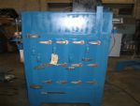 |  |  | Oven / Despatch / Style LTC2-1  Despatch Oven, Style LTC2-1, S/N 93869  Oven size: 24" x 24" x 36", gas  Heater: DG-50, Temp.: 450 degrees Fahrenheit  120v, 1ph, 60 cycle, 14.4 amp
7131 | 1 |  | Lab Equipment
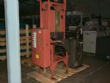 |  |  | Pad / L&W / Lab Pad, 14” w  L&W Lab Pad with Reliance variable speed Control 0-10, 14” wide, rubber/stainless rolls, 5” diameter, with a dip pan and feeds into a Infrared Pre-dryer, with (4) infrared heaters per side, total of 8 heaters. 240 Volts, 60 Amps, 3 phase

Lot # |  | Description
5746 | 1 | Lab Equipment
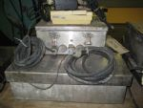 |  | Scale / Toledo / 20” x 20” Platform  Toledo Scale, Model 8142, RAM 1008, S/N 4290664-401, 120 Volt, 28 Amp, 50/60 Hz, Class III/IIIL, N Max. 10000, 20” x 20” platform
5748 | 1 | Lab Equipment
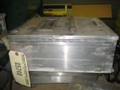 |  | Scale / Toledo / 66 lbs (30 kg) capacity, 14” x 14” Platform
n/a | 1 | Dyeing Printing & Finishing
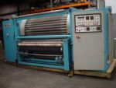 |  | Napper / Comet / 32-roll, double action, 78” wide  Comet Napper, 78" Wide, Double Action, 32 Rolls, Type: CYGNUS-X1, Exit Folder, Serial Number 31D6356
9368 | 1 | Dyeing Printing & Finishing
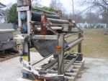 |  | Nip Stand / Morrison / 84” wide, 2-compensator  Morrison Nip Stand & 2-compensator  - Morrison Nip Stand year 1994, S/N T-898. Rolls: (1) Rubber Roll 84” wide x 12” dia., (1) SS Roll 84” wide x 12” dia., (1) Bow Roll 84” wide x 4” dia.  - (2) Compensator with 1-Roll each 84” wide x 6” dia., with (3) SS Rolls on stand with nip and compensator 84” wide x 6” dia.
9390 | 1 | Dyeing Printing & Finishing
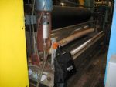 |  | Pad / Morrison / 120” w, 10 Ton, pneumatic  Morrison Pad Model T922 year 1995, 120” wide, 1-Rubber 1-Stainless 18” diameter rolls, 10 Ton pneumatic, Bow roll 122” wide x 6” diameter,1-SS roll 120” wide x 6” diameter in single dip pan and motor.  Motor: 25 HP DC, Type CD287ATC, Model 5CD173VC001A005, S/N VG-8-432-VG, 1750 rpm, 240 Volt 93.5 Amp.

Lot # |  | Description
4901 | 1 | Dyeing Printing & Finishing
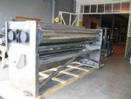 |  | Pad / Kuster / 2-Roll, 131” w, with drive motor  Kuster Horizontal 2-Roll Pad 131” wide, Type 22580, year 1992, Order M18052. Rolls are 1-Rubber and 1-SS 131” wide x 18” diameter. With: 1-SS Roll 141” x 6” dia., 2-SS Roll 131” wide x 6” dia., 1-SS Roll 126” wide x 6” dia.  Drive Motor: 20HP, 240 Volt, 2.71 Amp, 1750/2300 rpm, Frame LC2113ATCZ, ID No. 02KA586153-RS
2422 | 1 | Dyeing Printing & Finishing
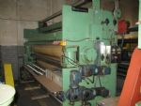 |  | Pad / Menzel / 2-roll, 138” wide, yr. 2002  Menzel 2-roll Pad, Rubber/Rubber 138" wide driven scroll rolls, type 138 PA, S/N 05133, Year 2002, 20 HP Inverter AC Drive, 230/460 3/60.  Rolls: (2) Rubber Rolls 138” x 12-1/2” dia, (3) Scroll Rolls 138” x 4” dia, (7) SS Roll 138” x 4” dia, (1) Rubber Roll 138” x 7” dia, low liquor ratio, single dip pan  Motor: Model KS256BCT205B, 230/460 Volt, 45.5/22.7 Amp, 1765 rpm, 20 HP, S/N LNG12B461004  Scroll motor Type DFT80N4, 230/460 Volt, 60 Hz, 3.70/1.83 Amp, 1 HP, 1700 rpm
2425 | 1 | Dyeing Printing & Finishing
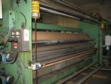 |  | Pad / Menzel / 2-roll, 138” wide, yr. 2004  Menzel 2-roll Pad, Rubber/Rubber 138" wide driven scroll rolls, type 138 PA, S/N 05134, Year 2004, 20 HP Inverter AC Drive, 230/460 3/60  Rolls: (2) Rubber Rolls 138” x 12-1/2” dia, (3) Scroll Rolls 138” x 4” dia, (7) SS Roll 138” x 4” dia, (1) Rubber Roll 138” x 7” dia, low liquor ratio, single dip pan  Motor: Model 6M 256THTWA8038BAL, 230/460 Volt, 31.10/15.5 Amp, 1780 rpm, 20 HP  Scroll motor Type DFT80N4, 230/460 Volt, 60 Hz, 3.70/1.83 Amp, 1 HP, 1700 rpm
2423 | 1 | Dyeing Printing & Finishing
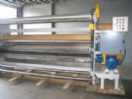 |  | Pad / KTM / 2-roll, 138” wide, yr. 1998  KTM 2-Roll Pad, Rubber/Rubber, 138" wide driven scroll rolls, S/N F970078-01-02, Year 1998, 20 HP Inverter AC Drive 230/460 volt, 3/60  Rolls: (2) Rubber Rolls 138” x 12-1/2” dia, (3) Scroll Driven Rolls 138” x 4” dia, (7) SS Roll 138” x 4” dia, (1) Rubber Roll 138” x 7” dia, low liquor ratio, single dip pan  Motor Model 7VL256THTNA803BBL, 230/460 Volt, 20HP, 31.0/15.5 Amp, 3 ph, 1780 rpm.  Scroll motor Type DFT80N4, 230/460 Volt, 60 Hz, 3.70/1.83 Amp, 1 HP, 1700 rpm, 3 ph
5838 | 7 | Dyeing Printing & Finishing
Print Head / for Stork RDIV, 22” wide
Sets for Stork RDIV, 22” Print Heads (Repeat sizes) (Box # 7)

Lot # |  | Description
5835 | 32 | Dyeing Printing & Finishing
Print Head / for Stork RDIV, 32” wide
(32 ½) Sets for Stork RDIV, 32” Print Heads (Repeat sizes)
(2) Box with 12-sets each (Box# 1 & 3)
(1) Box with 8 ½ -sets, ½ set = gear left side (Box# 2)
5840 | 18 | Dyeing Printing & Finishing
Print Head / for Stork RDIV, 27” wide
(18 ½) Sets for Stork RDIV, 27” Print Heads (Repeat sizes), with raised housing
(2) Boxes (Box #4 - 12 sets, Box #5 - 6 sets)
1/2 set = gear left side
5834 | 35 | Dyeing Printing & Finishing
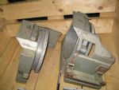 |  | Print Head / for Stork RDIV, 36” wide  Sets for Stork RDIV, 36” Print Heads (Repeat sizes)  (2) Box with 12-sets each (Box# 10 & 11)  (1) Box with 10-sets (Box# 9)  (1) Box with 1 - set (Box# 12)
5859 | 20 | Dyeing Printing & Finishing
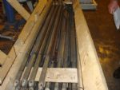 |  | Squeegee / 72-1/2” & 75” wide / Printing  Squeegee, with 6-rubbers  (9) 72-1/2” wide, 106” overall length  (11) 75” wide, 103” overall length
5833 | 14 | Dyeing Printing & Finishing
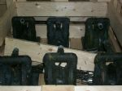 |  | Pump/ ARD / Air Color Pump  ARD Air Color Pump Model 666100, Max. Working pressure: 120 psi, 8-
4923 | 1 | Dyeing Printing & Finishing
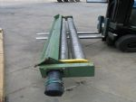 |  | Roll / Set of Scroll Rolls 126” wide  Set of Scroll Rolls 126” wide x 5” diameter, Model Catalog No. 9310009TF, Part No. 5002696, 1750 rpm, VDC 90, AVE 10.6, 1 HP, Ser. No. 2696

Lot # |  | Description
4938 | 1 | Dyeing Printing & Finishing
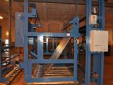 |  | Scray / Menzel / Tubular, 84” wide, with guiders  Scray consisting of:  A - Menzel J-Scray, tubular stainless steel 84” wide with 1-SS Roll 84” wide x 5” diameter, 1-Rubber Roll 84” wide x 7” diameter, Type 84SC, S/N 01179, year 1996  B - Light box 93” wide x 46” high. Over the light box there is 1- Steel Roll 84” wide x 5” diameter, 1- Set of tension Rods 84” wide and 1-SS Roll 82” wide x 4” diameter  C - 1-Set of 18” wide Guiders Specialty guides, Model 45, Right side mfgr. # P938, Left side mfgr. # X923
4903 | 1 | Dyeing Printing & Finishing
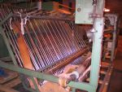 |  | J Scray / Tubular, 124” wide  J Scray (Tubular, SS) 124” wide  Rolls: 1-Steel Roll 126” wide x 5” diameter, 1-SS Roll 126” wide x 5” diameter, 1-SS Roll 124” wide x 5” diameter, 1-Covered Roll 126” wide x 8-1/2” diameter, 1-Rubber Roll 126” wide x 6-1/2” diameter  Motor: 3 HP, 1750/2300 rpm, 180 Volt, 24.1 Amp DC, Ser.No. PG-8-149-RG, Type CDL186 ATC, Model 5CD144U4C005B36
4904 | 1 | Dyeing Printing & Finishing
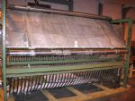 |  | J Scray /Inspection, 126” wide  J Scray (Inspection) 126” wide  Rolls: 3-SS Rolls 126” wide x 5” diameter, 1- Steel Roll 126” wide x 8” diameter, 1-Rubber Roll 126” wide x 7” diameter  Motor: 5 HP, 1750/2050 rpm, 180 Volt, 24.1 Amp, Ser. No. BG-8-155-RG, Type CD1186ATC, Model 5CD144UC005B036
7153 | 1 | Dyeing Printing & Finishing
Scray / Birch Brothers / J Scray, 130” working width
Birch Brothers “J” Scray, 130” working width
Rolls:
2-Driven Covered Rolls, 140” wide x 8” diameter
SS Roll, 130” wide x 6” diameter
SS Pat Roll, 130” wide x 6” diameter
SS Roll, 130” wide x 6” diameter
DC Motor: 7.5 HP, 1750/2300 rpm, Arm volt 500, Volt field 150/300, Model D5007P, BRG 10483-35, S/N N109/0040-SAP002

Lot # |  | Description
7154 | 1 | Dyeing Printing & Finishing
Scray / Birch Brothers / J Scray, 130” working width
Birch Brothers “J” Scray, 130” working width
Rolls:
2-Driven Covered Rolls, 140” wide x 8” diameter
SS Roll, 130” wide x 6” diameter
SS Pat Roll, 130” wide x 6” diameter
SS Roll, 130” wide x 6” diameter
DC Motor: 10 HP, 1750/2300 rpm, Model P21921480148, Arm volt 500, Field Volt 150/300, Amp 17.2, S/N N030/0539-000428-12
5910 | 1 | Embroidery & Sewing
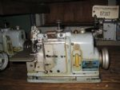 |  | Sewing machine / Merrow / M-1D-2, head only  Merrow Sewing Machine, Model M-1D-2, head only. S/N 227879
5921 | 1 | Embroidery & Sewing
Sewing machine / Merrow / with table and Air Motor
Merrow Sewing machine Style 70-Y3B, S/N 221337, with table and air motor
5923 | 1 | Embroidery & Sewing
Sewing machine / Merrow / with stand
Merrow Sewing machine Style 70-Y3B, S/N 217904, with stand. Run on 12V Battery
7140 | 1 | Embroidery & Sewing
Sewing machine / Merrow / Head 70-Y3B, with table
Merrow Sewing machine Style 70-Y3B, S/N 181035, with table
9553 | 1 | Embroidery & Sewing
Sewing machine / Merrow / Head 70-Y3B-2, head only
Merrow Sewing machine Style 70-Y3B-2, S/N 254060, head only
7138 | 1 | Embroidery & Sewing
Sewing machine / Merrow / 70-Y3B-2, Head only
Merrow Sewing machine Style 70-Y3B-2, S/N 249709, head only

Lot # |  | Description
5961 | 1 | Embroidery & Sewing
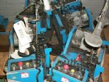 |  | Sewing machine / Railway, 77” w, with Merrow head  Railway Sewing Machine 77" wide, S/N 263926, with Merrow head 72-D3B. Rail Birch Bros S/N 155
5962 | 1 | Embroidery & Sewing
Sewing machine / Railway, 77” w, with Merrow head
Railway Sewing Machine 77" wide, S/N 267622, with Merrow head 70-Y3B-2. Rail Birch Bros S/N 155 016
5963 | 1 | Embroidery & Sewing
Sewing machine / Railway, 77” w, with Merrow head
Railway Sewing Machine 77" wide, s/n 263928, with Merrow head 72-D3B. Rail Birch
5964 | 1 | Embroidery & Sewing
Sewing machine / Railway, 77” w, with Merrow head
Railway Sewing Machine 77" wide, s/n 263829, with Merrow head 72-D3B. Rail Birch Bros S/N 155 015
5965 | 1 | Embroidery & Sewing
Sewing machine / Railway, 77” w, with Merrow head
Railway Sewing Machine 77" wide, s/n 263927, with Merrow head 72-D3B. Rail Birch
5967 | 1 | Embroidery & Sewing
Sewing machine / Railway, 94” w, with Merrow head
Railway Sewing Machine 94" wide, s/n 217596, with Merrow head 70-D3B-2. No name tag

Lot # |  | Description
7657 | 1 | Embroidery & Sewing
Sewing machine / Railway, 96” ww, with Merrow head
Railway Sewing Machine, with Merrow Model 70-Y3B-2 sewing head, S/N 245332
5968 | 1 | Embroidery & Sewing
Sewing machine / Railway, 97” w, with Merrow head
Railway Sewing Machine 97" wide, s/n 216032, with Merrow head 70-D3B-2. No name tag
n/a | 1 | Dyeing Printing & Finishing
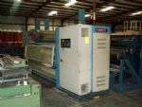 |  | Shear / Comet / 86” wide  Comet "Orion" Shear 86" wide, model 2000, year 1995, #C1146, Corino Guider with pivot bar.
2438 | 1 | Tank
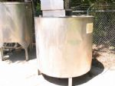 |  | Tank / Stainless Steel, 400 gallon, with mixer  Stainless Steel Tank, 400 gallon, 2-1/2” drain hole with top on legs, 48”x48”, with Mixer Model 3KW94G, 1.5 HP, 60 HZ, 208-230-460 Volt, 4.5 - 4.1 - 2 Amp, 1730 rpm, S/N CQM535420233
2439 | 1 | Tank
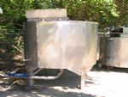 |  | Tank / Stainless Steel, 400 gallon, with mixer  Stainless Steel Tank, 400 gallon, 4” drain hole with top on legs, 48”x48”, with Mixer Model M3558T, 2 HP, 208-230-460 Volt, 6.5 - 6.2 - 3.1 Amp, 1725 rpm, 60 Hz, S/N 35A01-872
2440 | 1 | Tank
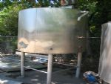 |  | Tank / Stainless Steel, 400 gallon, with mixer  Stainless Steel Tank, 400 gallon, 4” drain hole with to on legs, 48”x48”, with Mixer S/N 1-5104-12988-2-39, Type GK, 1 HP, 60Hz, 1150 rpm, 550 Volt, 1.56 Volt, 3 phase

Lot # |  | Description
5953 | 1 | Dyeing Printing & Finishing
Tenter Chain / M&W / Reconditioned
M&W Tenter Chain Reconditioned 300s Spring Loaded closed
M&W 300 Spring Loaded Closed 288 Links
M&W 300 Spring Loaded Closed 288 Links
M&W 300 Spring Loaded Closed 116 Links
M&W 300 Spring Loaded Closed 288 Links
TOTAL 980 Links
Shop order No. 36654
5954 | 1 | Dyeing Printing & Finishing
Mercerizer Chain / M&W / Reconditioned
M&W Mercerizer Chain Reconditioned
M&W 48 with Diversified Bottom 189 Links
M&W 48 with Diversified Bottom 189 Links
M&W 48 with Diversified Bottom 135 Links
M&W 48 Tops Pin & Links 99
M&W 48 Diversified Bottom 189 Link
M&W 48 Diversified Bottom 189 Link
TOTAL 990 Links
5970 | 1 | Dyeing Printing & Finishing
Mercerizer Chain / M&W / Reconditioned
M&W Reconditioned 8 Mercerizer Chain 120 Links
TOTAL 120 Links
5950 | 1 | Dyeing Printing & Finishing
Mercerizer Chain / M&W / Used
M&W Used #48 Mercerizer Chain
(2) boxes w/360 links each = TOTAL 720 links
5972 | 1 | Dyeing Printing & Finishing
Tenter Chain / M&W / Used
M&W Used 300 Chain Spring Loaded closed
From #3 Clip Left Side - 477 Links
From #3 Clip Right Side - 477 Links
TOTAL 954 Links
5973 | 1 | Dyeing Printing & Finishing
Tenter Chain / M&W / Used
M&W Used 300 Chain Not Spring Loaded
From #1 Clip Left Side - 475 Links
From #1 Clip Right Side - 475 Links
TOTAL 950 Links
5997 | 1 | Dyeing Printing & Finishing
Mercerizer Chain / M&W / #48, Used
M&W Used #48 Mercerizer Chain
(2) boxes w/500 links each (right and left hand) = TOTAL 1000 links

Lot # |  | Description
6677 | 1 | Dyeing Printing & Finishing
Tenter Rails / Morrison / 80” wide, year 1994
Set of Morrison Tenter Frame Rails, 80” wide x 80’ long, clip type chain. Mercerizer Rails, Cross Members and Drive End.
9532 | 1 | Dyeing Printing & Finishing
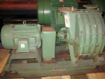 |  | Vacuum Slot-Extractor Dry / EVAC / With vacuum pump and motor  EVAC Vacuum Slot-Extractor Dry, with vacuum pump and 25 HP motor. EVAC Pump Type STF25/575 yr. 1993. Motor: TIKK, 575 Volts, 3 phase, 25 HP, 60 Hz, 3515 rpm, 23 Amps. (2) 80" Slot
7200 | 1 | Dyeing Printing & Finishing
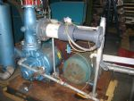 |  | Vacuum Pump / Nash  Nash Vacuum Pump Size SC 6/4, Test No. 93D1010, 1770 rpm  Motor: MFG’R Reliance 40 HP, Frame 32470, S/N GIS48562, 40 Amp, 575 Volts, 1770 rpm, 88” wide slot
2955 | 1 | Dyeing Printing & Finishing
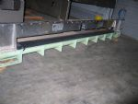 |  | Vacuum Slot / EVAC / Adjustable, 84” wide  EVAC Vacuum Slot 84” wide, adjustable
9363 | 1 | Dyeing Printing & Finishing
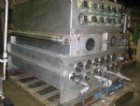 |  | Wash Box / Morrison / SS, double lace, 84” wide, yr. 1991, with nip stand  Morrison Wash Box with nip stand  - Morrison Totally enclosed SS Wash Box, Model DLE 6, double lace, 1991 yr., 84” wide, with 12-Top rolls up & 13-Botom rolls all 84” wide x 6” diameter.  Wash Box outside dimensions: 90-1/2” wide x 84-1/2” F.B. x 71” High  External sealed immersion roll bearings. (Lot 9363)  - Morrison Nip Stand year 1991, S/N T-861: (1) rubber roll 84” wide x 12” dia., (1) SS Roll 84” wide x 12” dia.  Nip motor Model AVF215THTS8038BRL, 10 HP, 230/460 Volt, 3 ph, 60 Hz, 1775 rpm, Type TTS (Lot 9364)

Lot # |  | Description
9360 | 1 | Dyeing Printing & Finishing
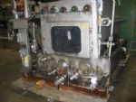 |  | Wash Box / Morrison / SS, single lace, 84” wide, yr. 1994, with nip stand  Morrison Totally enclosed SS Wash Box, Model SLE 6, single lace, 1994 yr., S/N T896, 84” wide, with 5-Top rolls & 6-Bottom rolls all 84” wide x 6” diameter.  Wash Box outside dimensions: 90” wide x 66” F.B. x 59” High  External sealed immersion roll bearings.  1-Morrison 84” wide Nip stand, with 1-Rubber roll and 1-SS roll both 84” x 11-1/2” diameter, 5 Ton pneumatic, one bow roll 84” wide x 4” diameter and 10HP motor 230/460V 1750 rpm.
7161 | 1 | Dyeing Printing & Finishing
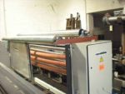 |  | Weft Straightener / Mahlo / 128” wide, yr. 2000  Mahlo Weft Straightener, Type RFMC-96H, 128” wide, year 2000, Fabric Nr. 22/686H/13541, 6- Ele optical eyes 514 HD-R 58843.  Rolls: 5-SS Rolls 128” wide x 4” diameter, 2-SS Rolls 130” wide x 6” diameter, 3-Bow Rolls 128” wide x 4” diameter  480 Volts, 3 ph, AC, 3.42 Amp, 60 Hz  Does not have computer - has manual controls
9584 | 1 | Dyeing Printing & Finishing
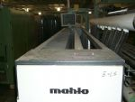 |  | Weft Straightener / Mahlo / 142.5” wide, yr. 2002  Mahlo Weft Straightener Type RFMC-10A, Fabr. Nr. 25/686/30806, JHR 8.02.  Rolls: (7) Stainless Steel Rolls, 142-1/2” wide x 4” diameter and (2) Rubber Bow Rolls, 142-1/2” wide x 4” diameter. With (6) Mahlo Sensors I.D. Tag No.: NO I.D. Tag, 599 P 4655, 599 P 4654, 599 P 4653, 599 P 4652, 599 P 4651. 230/400 Volts, 6.00 Amps, 60 Hz
5958 | 12 | Dyeing Printing & Finishing
A-Frame / Brakes
A-Frame Air Brakes
4902 | 1 | Dyeing Printing & Finishing
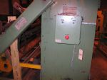 |  | A-Frame / Cooper / Surface Winder, electric, 126” wide  Cooper A-Frame Surface Winder, electric, 126” wide.  Rolls: 3-Steel Rolls 126” wide x 5” diameter, 1- SS Roll 126” wide x 5” diameter, 1-Bow Roll 128” wide x 5” diameter, 2-Steel Rolls 126” wide x 8” diameter  Motor: 20 HP, 1750/2300, 240 Volt, 1.78/1.2 Amp, Type CD259ATC, Model 5CD1644UC024A006

Lot # |  | Description
4941 | 1 | Dyeing Printing & Finishing
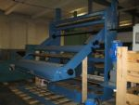 |  | A-Frame / Menzel / Wind-Up, 88” wide, yr. 1991 with walk board & Inspection station  A-Frame Wind-Up consisting of:  A) Walk Board with 2-Steel Rolls 84” wide x 5-1/2” diameter  B) Inspection station with 5-SS Rolls 84” wide x 5” diameter  C) Menzel A-Frame Wind-Up 88” wide, S/N 03083 year 1981. With 2-Steel Rolls 88” wide x 8” diameter, 1-SS Roll 88” wide x 4” diameter, 1-SS Roll 88” wide x 6” diameter, 1-Steel Roll 92” x 5” diameter. Drive motor: 10HP, 230/460 Volt, 23.8/11.9 Amp, 50/60 Hz, 135-1755 rpm, S/N O1UB263526G1ZY. With hydraulic pump for raising and lowering the arm
9587 | 1 | Yarn Manufacturing
Applicator / Foam applicator, 60” slot
Foam Applicator with 60” slot, Hydralign Controls Model C7021 on right and left side with Hydralign guides, moveable manual enter roll.
Hydralign control on right side: S/N H60820, Voltage 117/60
Hydralign control on left side: S/N H60829, Voltage 117/60
4914 | 1 | Dyeing Printing & Finishing
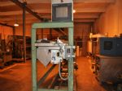 |  | Applicator / WEKO / Spray Unit, 132” wide  Weko Spray Unit sold by Consoltex, 2001 Model 10/140/1/34/320-12G Spray Applicator, S/N 27313, 132” wide, with a heated mixing tank.  Motor: ½ HP, 1725 rpm, 230/460 Volt, 1.6/.8 Amp, Cat No. CWCM-3538
2416 | 1 | Dyeing Printing & Finishing
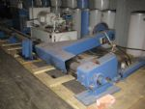 |  | Batcher / Krantz / 140" wide, Beam Winder/Unwinder  Krantz Beam Winder/Unwinder, center wind, Model DBGW, S/N 8283, 140" wide, maybe 148" max., hydraulic pump 20 HP, 230/460 volts 3/60, control panel.  Motor: Model AP AF4P20TC51L, Prod# LM1524988, 20HP, 1750/1450
2907 | 1 | Dyeing Printing & Finishing
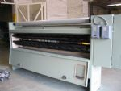 |  | Brush / James Hunter / Model BM-108  James Hunter 4 Roll Brush machine, Model BM-108, S/N FM-7580  Reconditioned  4 brushes 108" x 6" dia  2 steel rolls 108" x 5" dia, 1 steel roll 114" x 5" dia

Lot # |  | Description
538 | 1 | Dyeing Printing & Finishing
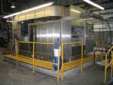 |  | Scouring machine / Zonco / Year 1998  Zonco Machine to scour soften and dry woven & knitted fabrics in rope form, 2-section, Model EOLO, S/N 95.97.16, year 1998, with gas fired burner at exit for burning off all the pilling waste after scouring and washing, with computer controls, driven entrance and exit. 400V A/C / 60 / 3, absorbed power 61 KW, current intensity 140A, exit power 45 Hp. Heating elements power 400 KW, min. pressure air 500 KPA. Max. pressure air 800 KPA. FAB/Mfg. Zonco Federico, type: Secheclee, 120V/5 Amp 1,200,000 BTU per hour.
4893 | 1 | Dyeing Printing & Finishing
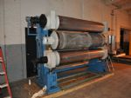 |  | Calender / B.F. Perkins / 3-roll, 100" w, yr. 1994  B.F. Perkins Calender, 3-roll, Model FHTS-90-1, S/N H-9323, year July 1994  - Top and Bottom rolls are Steel 101" wide x 16" diameter, hot oil heated; Middle Roll filled 100” wide x 22” diameter. With 2-Filled extra rolls 100” wide, (one new 24” diameter and another used 20” diameter)  - Hydraulic Oil Pump motor tag: Cat M3708T-5, Spec 37A01Y34, Frame 215 T, Ser. No. F194, 5 HP, 575 Volt, 3 ph, 60 Hz, 6.3 Amp, 1160 rpm  - Smaller Hydraulic Oil Pump motor tag: Cat M33534-5, Spec 34A61-901, Frame 56, Ser. No. W9-93, .33 HP, 575 Volt, 3 ph, 60 Hz, .64 Amp, 1725 rpm  - Drive motor: 75 HP, Frame LC2812T2, ID No. 05KA593429-UW, 500 Volt, 126 Amp, 1750 rpm, max. speed 4500
4911 | 1 | Dyeing Printing & Finishing
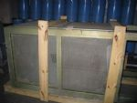 |  | Dust House / 15 HP blower fan  Dust House 40” x 40” x 70” with blower fan 15 HP, Ser. No. 1090C, Cat M23387-5,Frame 254T, 575 Volt, 15.7 Amp, 1760 rpm, 60 Hz, 3 ph
5912 | 1 | Dyeing Printing & Finishing
Collection System / Suction Fan and Lint Collector
Suction Fan and Lint Collector. Motor: 20 HP, 575 Volts, 18 Amp, 1755 rpm, Type AEEA, Frame TEFC 256T, 60 Hz, 3 ph, S/N FFH 1554 25007. Lint Box Size 75 ½” long x 42” wide x 84” high
4906 | 1 | Dyeing Printing & Finishing
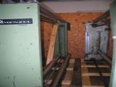 |  | Compensator / Menzel / 4-stainless steel rolls, 110” wide  Menzel Compensator Type 110CP, S/N 05093, year 7/1994, 4-stainless steel rolls, 110” wide x 5” diameter

Lot # |  |  |  | Description
4908 |  |  | 1 | Dyeing Printing & Finishing
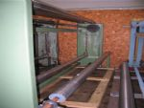 |  |  |  | Compensator / Cooper / 2-SS & 2-steel rolls, 120” wide  Cooper Compensator, No Tag, 2-SS & 2-steel rolls 120” wide x 5” diameter
4907 |  |  | 1 | Dyeing Printing & Finishing
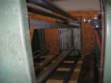 |  |  |  | Compensator / Cooper / 3-stainless steel rolls, 126” wide  Cooper Compensator, No Tag, 3-stainless steel rolls, 126” wide x 5” diameter
4909 |  |  | 1 | Dyeing Printing & Finishing
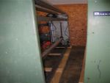 |  |  |  | Compensator / Cooper / 3-SS Roll, 126" wide  Cooper Compensator No Tag, 1-SS Roll 141” wide x 6” diameter and 2-SS Roll 126” wide x 5” diameter
7158 |  |  | 2 | Dyeing Printing & Finishing
Compensator / 3-Roll, 130” wide
3-Roll Compensator, 130” wide
3-SS Rolls, 130” wide x 6” diameter
Lot# 7158 & 7159
7160 |  | 1 |  | Dyeing Printing & Finishing
Compensator / 3-Roll, 130” wide
3-Roll Compensator, 130” wide
2 – Steel Rolls, 130” wide x 3” diameter
1 – SS Roll, 126” wide x 4” diameter
9379 | 4 |  |  | Dyeing Printing & Finishing
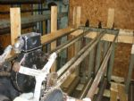 |  |  |  | Compensator / 80” wide  Compensator with 80” wide x 5” diameter SS roll. Can go 32” high on working

Lot # |  | Description
4000 | 1 | Dyeing Printing & Finishing
Compensator / 3-Roll, 85-1/2” wide
3-Roll 85-1/2” wide Compensator with 2-SS Rolls 86” wide x 5” diameter and 1-SS Roll 85-1/2” wide x 5” diameter
5456 | 1 | Dyeing Printing & Finishing
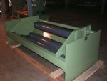 |  | Cradle / Menzel / 4-roll, 110" wide  Menzel 4 Roll cradle let off, 110" wide x 8 ¼” Ø rolls.
9392 | 20 | Dyeing Printing & Finishing
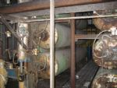 |  | Dry Can / Morrison / 2-Stacks of 10 Dry Cans 120” wide, with motor  Dry Cans 120” wide in 2-stacks of 10 Dry Cans each  (1) Stack of 10 Morrison Dry Can 120” wide x 23” diameter, 8-year 1987 & 2-Year 1995, max. wp 105 psi at 341°F, Shell TH, with syphons, joints and traps. Set is driven for a DC motor. Motor: 10 HP, 1750/2300 rpm, 240 Volt, 36.6 Amp, Type CD219ATC, Mod 5CD153RC015B800, S/N NK-8-232-NK (Lot 09392)  Nat’l BD S/N Year  23643 T23925 1987  23648 T23930 1987  23644 T23926 1987  23638 T23920 1987  23642 T23924 1987  23636 T23918 1987  23649 T23931 1987  23647 T23929 1987  28816 T29100 1995  28794 T29078 1995  (1) Stack of 10 Morrison Dry Can 120” wide x 23” diameter, year 1995, max. wp 105 psi at 341°F, Shell TH, with syphons, joints and traps. Set is driven for a DC motor. Motor: 10 HP, 1750/2300 rpm, 240 Volt, 36.6 Amp, Type CD219TC, Mod 5CD153RC015B001, S/N UR-8-243-VR (Lot # 09393)  Nat’l BD S/N Year  28800 T29084 1995  28824 T29108 1995  28798 T29082 1995  28810 T29094 1995  28823 T29107 1995  28826 T29110 1995  28805 T29089 1995  28809 T29093 1995  28828 T29112 1995

Lot # |  |  | Description
4940 |  | 48 | Dyeing Printing & Finishing
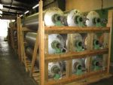 |  |  | Dry Can / Sims / 4-sections of 12-dry cans 84” wide  Sims Dry Cans, 4 sections of 12 cans each, 84” wide x 23” diameter x 75 psi, with syphons, joints, traps, v-belt pulleys and stands
4942 |  | 7 | Dyeing Printing & Finishing
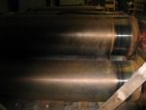 |  |  | Dry Can / Morrison / Cooling Can, 84” wide, yr 1994  Morrison Textile Machinery Dry Cans (cooling), 84” wide x 23” diameter, S/N 28369, year 1994. No frame work  MAWP 73 psi at 318 deg. F, MDMT 18 deg. F at 73 psi
4910 |  | 5 | Dyeing Printing & Finishing
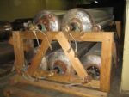 |  |  | Dry Can / 96” wide x 23" diameter, yr. 1990  Dry Can 96” wide x 23” diameter, year 1990. Pressure Vessels Inc. Nat’l Board maximum allowable 75 psi at 320 deg. F, minimum design metal temp 0 deg F at 75 psi.
7220 |  | 1 | Yarn Manufacturing
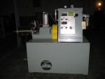 |  |  | Foamer / EASE  EASE Foamer. Drive Motor: Model 5CD124TP0018, 2HP, 180 Volt, 9.8 Amp, 1750 rpm. Foamer Motor Model B0054FLFZ0M, 5 HP, 575 Volt, 5.2 Amp, 3 ph, 1730 rpm  NO ID Tag
2421 |  | 1 | Dyeing Printing & Finishing
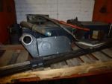 |  |  | Rail Guide / Erhardt & Leimer / Set, No tag  Set of Erhardt & Leimer Rail Guides, with E&L sensors with Tandematic plate guides, controls, electric motors for power opening. Right & Left side. No Tag
2426 | 1 |  | Dyeing Printing & Finishing
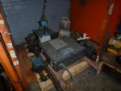 |  |  | Rail Guide / Erhardt & Leimer / Set, Type FR5501  Set of Erhardt & Leimer Rail Guides, with E&L sensors with Tandematic plate guides, controls, electric motors for power opening. Right Side: Type FR5501, No. 222331, ID 820004456 & Left side: Type FR5501, No. 222331, ID 820018736

Lot # |  |  | Description
2424 |  | 1 | Dyeing Printing & Finishing
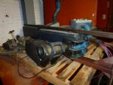 |  |  | Rail Guide / Erhardt & Leimer / Set, No tag  Set of Erhardt & Leimer Rail Guides, Tandematic plate guides, controls, electric motors for power opening. Right Side & Left side. No Tag  *Don’t have the eye
5940 |  | 1 | Dyeing Printing & Finishing
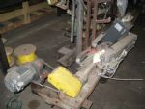 |  |  | Guider / Erhardt & Leimer / Set of guiders, 18” wide, 120” ww  Set of Erhardt & Leimer Air Guiders, 18” wide. Right: Model KF1224, TNR 56644, Left: KF1224, TNR 56643, 120” working width. (Rolls: Steel over rubber)
5829 |  | 1 | Dyeing Printing & Finishing
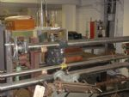 |  |  | Guider / Erhardt & Leimer/ 80” working width  Set of E&L Type K F10/ EI Guiders. Left & Right 11” wide. 80” Working width
n/a | 1 |  | Dyeing Printing & Finishing
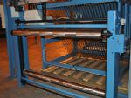 |  |  | Inspection machine / In Line Inspection and A-Frame Wind-Up  In Line Inspection and A-Frame Wind-Up consisting of:  1) One 3-Roll 85-1/2” wide Compensator with 2-SS Rolls 86” wide x 5” dia. and 1-SS Roll 85-1/2” wide x 5” dia.  2) Hunter Lab Color Management System SpectraProbe XE, Model 80223158, S/N 039723801A, 104” wide  The SpectraProbe XE online color measurement system can be used to measure the color of the fabric as it exits in a textile finishing range (typically after the drying cans or tenter oven). The sensor traverses over the surface of the fabric so side-center-side shading differences can be assessed and immediate adjustments made to the range based upon these values. The colormetric results are displayed on screen and users are alarmed when the tolerances for these are exceeded  The system has provision for analog/digital outputs, which serve to report color data to a plant DCS or PLC control system, allowing color measurement data to be used in the control of range process variables  3) Scray consisting of:  A - Menzel J-Scray, tubular stainless steel 84” wide with 1-SS Roll 84” wide x 5” diameter, 1-Rubber Roll 84” wide x 7” diameter, Type 84SC, S/N 01179, year 1996  B - Light box 93” wide x 46” high. Over the light box there is 1-Steel Roll 84” wide x 5” diameter, 1- Set of tension Rods 84” wide and 1-SS Roll 82” wide x 4” diameter  C - 1-Set of 18” wide Guiders Specialty guides, Model 45, Right side mfgr. # P938, Left side mfgr. # X923  4) A-Frame Wind-Up consisting of:  A - Walk Board with 2-Steel Rolls 84” wide x 5-1/2” diameter  B - Inspection station with 5-SS Rolls 84” wide x 5” diameter  C - Menzel A-Frame Wind-Up 88” wide, S/N 03083 year 1981. With 2-Steel Rolls 88” wide x 8” diameter, 1-SS Roll 88” wide x 4” diameter, 1-SS Roll 88” wide x 6” diameter, 1-Steel Roll 92” x 5” diameter. Drive motor: 10HP, 230/460 Volt, 23.8/11.9 Amp, 50/60 Hz, 135-1755 rpm, S/N O1UB263526G1ZY. With hydraulic pump for raising and lowering the arm

